RESOLUTION NO.__________

RE: CERTIFICATE OF APPROPRIATENESS UNDER THE
PROVISIONS OF THE ACT OF THE PENNSYLVANIA
LEGISLATURE 1961, JUNE 13, P.L. 282 (53
SECTION 8004) AND BETHLEHEM ORDINANCE NO.
3952 AS AMENDED.

WHEREAS, it is proposed to remove existing slates and install new Ecostar imitation slate at 404 Center Street.

NOW, THEREFORE, BE IT RESOLVED by the Council of the City of Bethlehem that a Certificate of Appropriateness is hereby granted for the proposal.

Sponsored by: (s)

(s)

ADOPTED BY COUNCIL THIS DAY OF

(s)
President of Council

ATTEST:

(s)
City Clerk

HISTORICAL & ARCHITECTURAL REVIEW BOARD

The applicant proposes to re-roof the Carriage House at
404 Center St.
APPLICATION #3:

Bruce Lawrence
404 Center St., Bethlehem, PA 18018

OWNER:

__________________________________________________________________

The Board upon motion by Gen Marcon and seconded by Nancy Shelly adopted the proposal that City Council issue a Certificate of Appropriateness for the following:

- Remove existing slates and install new Ecostar imitation slate.

- Slate color to be Federal Gray with copper flashing.

3. Re-use existing snow guards or replacement if necessary.

4. The motion was unanimously approved.

__________________________________________________________________________

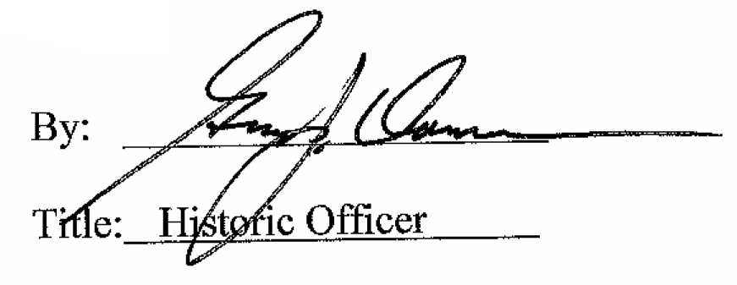

Date of Meeting: September 2, 2015

